CALL CENTER DATA ANALYSIS

NAME: Sayantan Malladeb

CONTACT: [sm103@illinois.edu](mailto:sm103@illinois.edu)

**Setting up the data table for analysis :**

The main table for our analysis was constructed using 3 tables namely, Chicago_crimes_2021, Chicago_areas and Chicago_temps_2021.

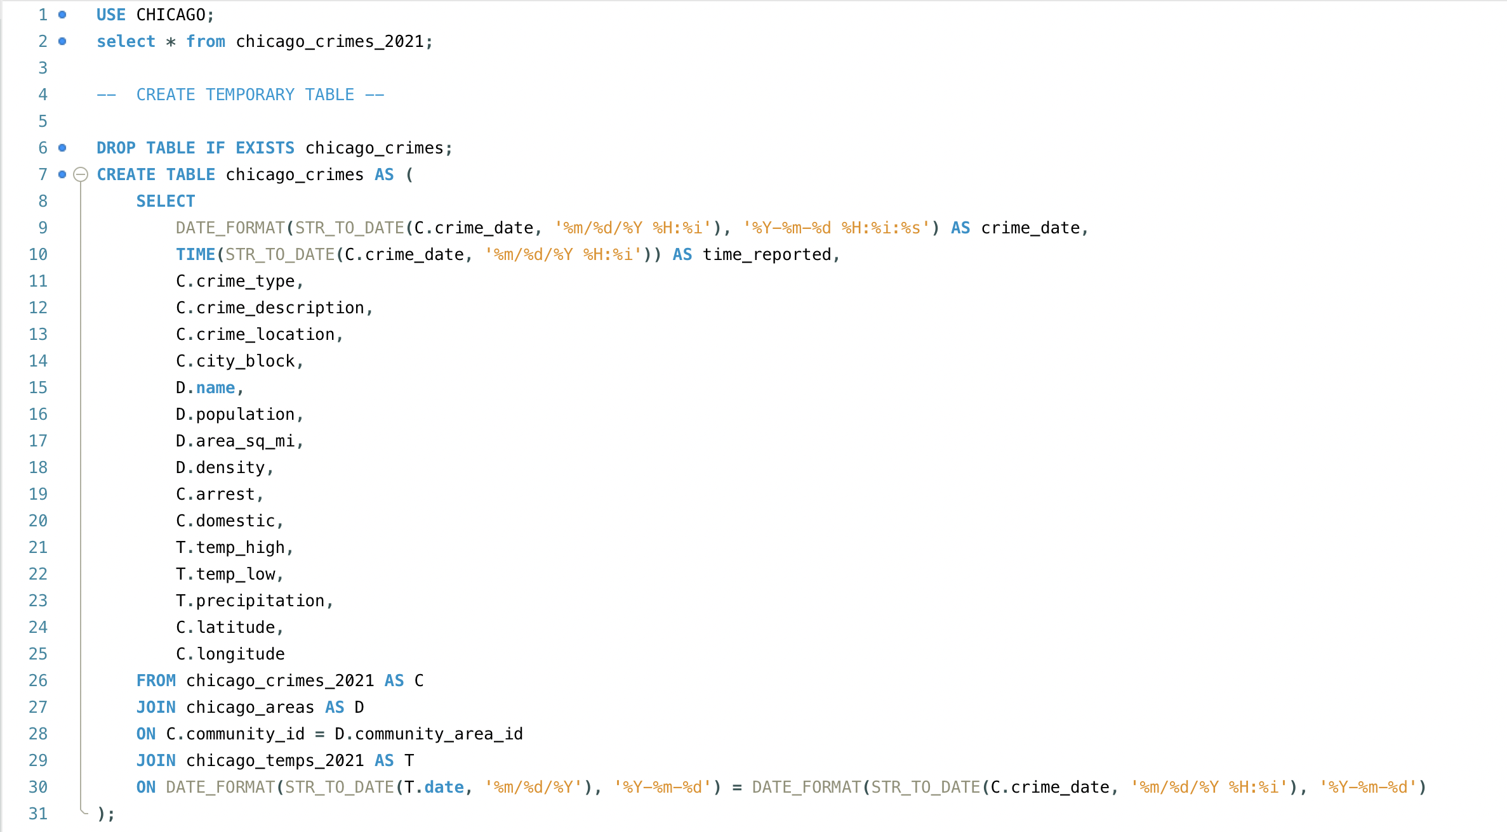

*Insightful questions and information regarding data analysis:*

1. 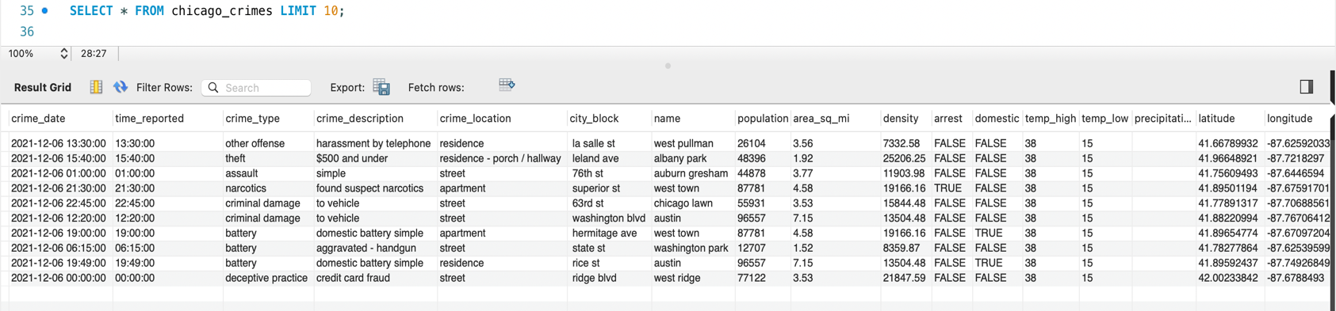What are the columns on our new table ?
2. What is the total number of reported crimes in Chicago city?

RESULT:

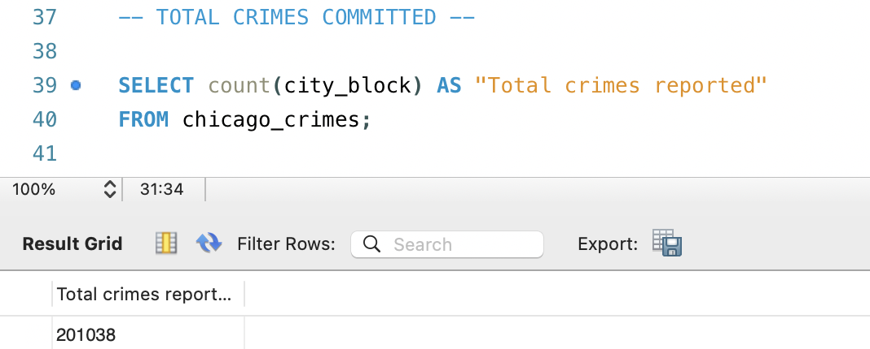

1. What are the top 10 types of crimes committed?

RESULT:

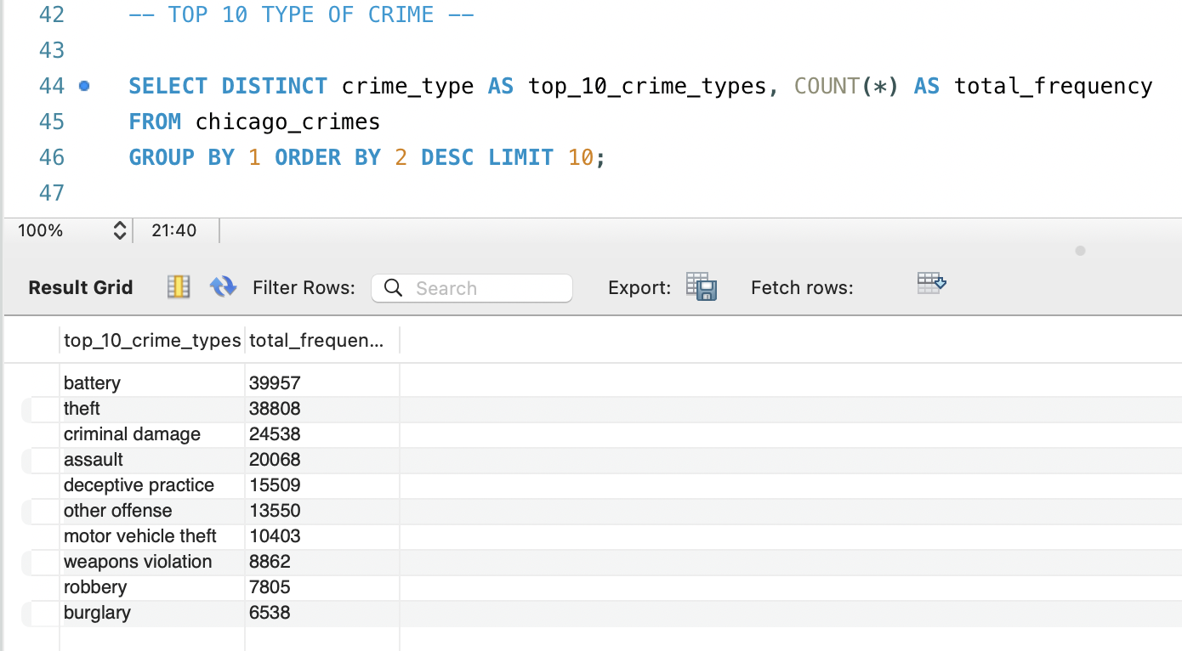

1. What is the highest number of consecutive days where a homicide occurred in the city?

RESULT:

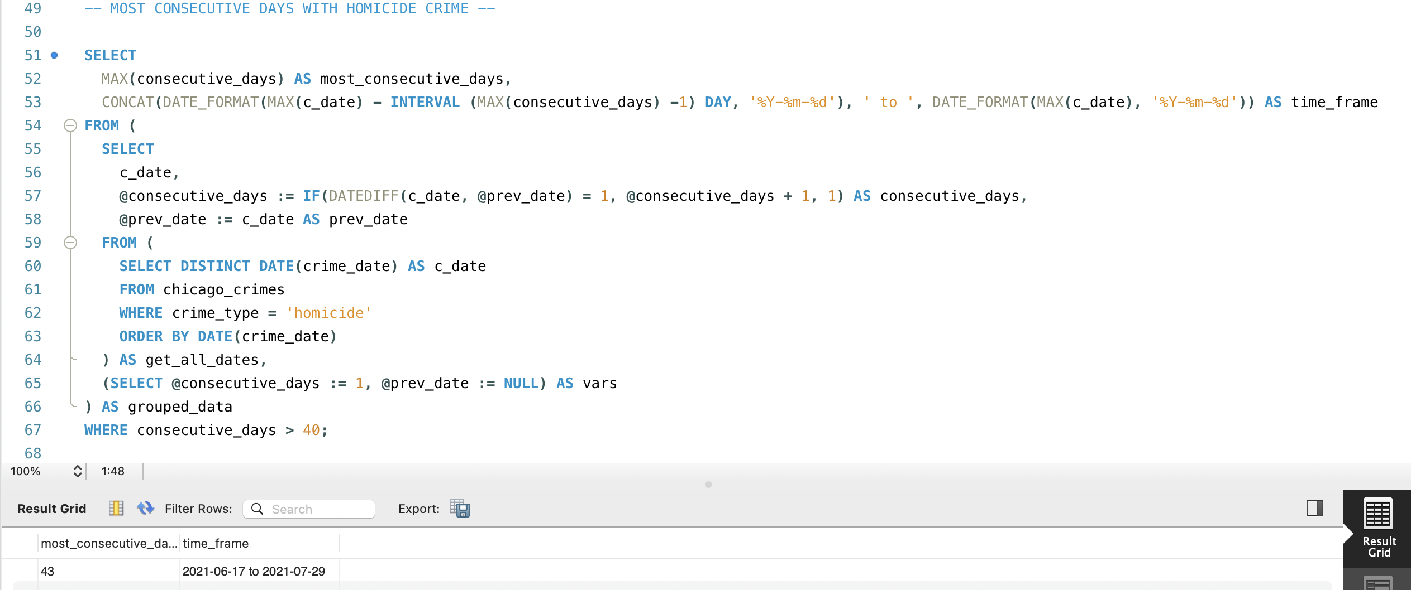

1. What are the top 10 safest and top 10 most dangerous communities in Chicago?

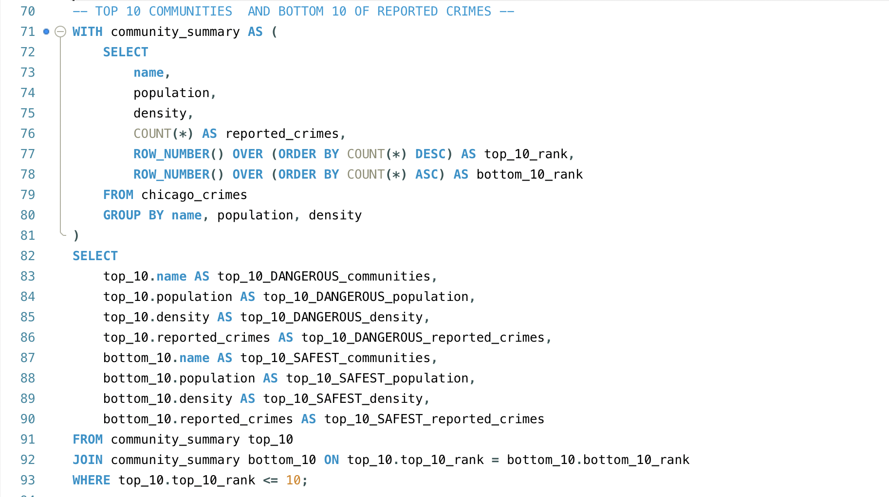

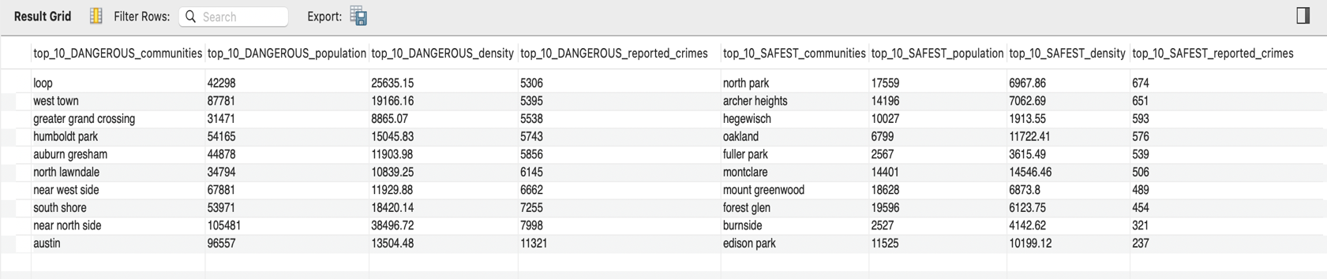RESULT:

1. What are the top 15 types of crimes occurring in the city?

RESULT:

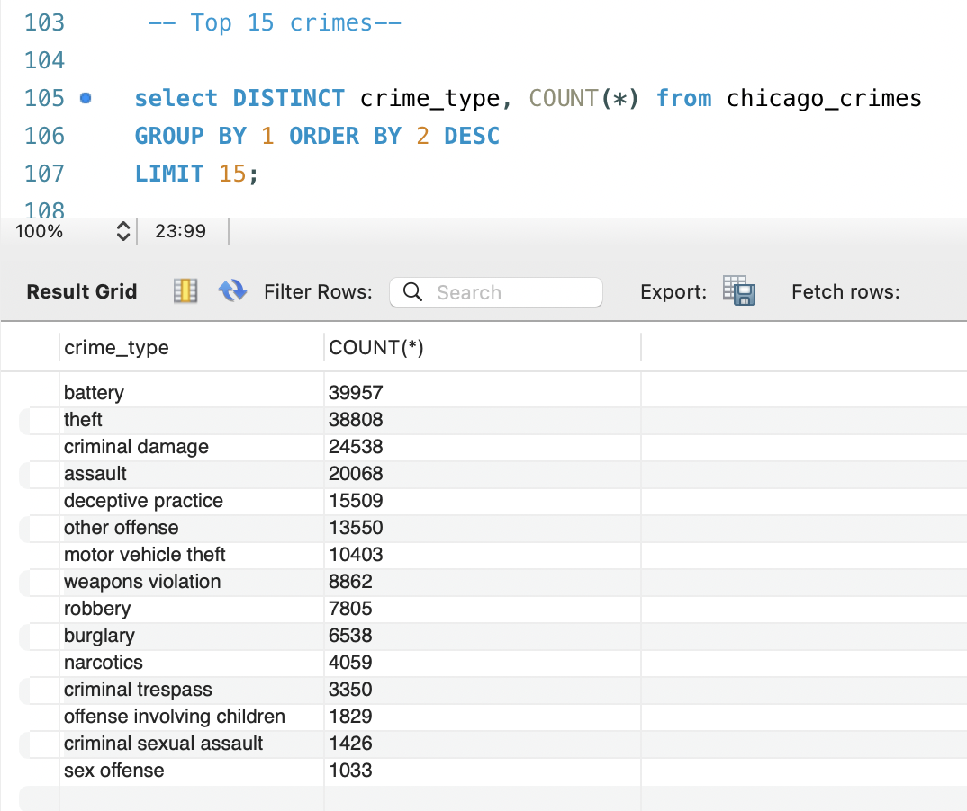

1. What are the top 10 most unsafe streets in Chicago?

RESULT:

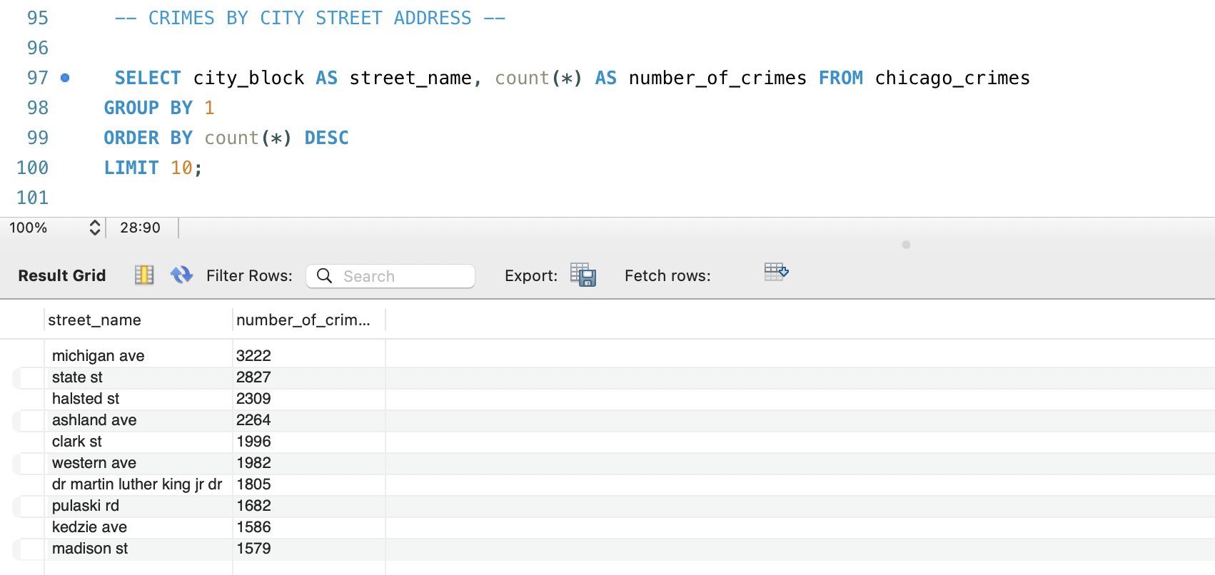

1. age customer satisfaction score by state?
2. What are the top 10 streets by number of occurring assaults?

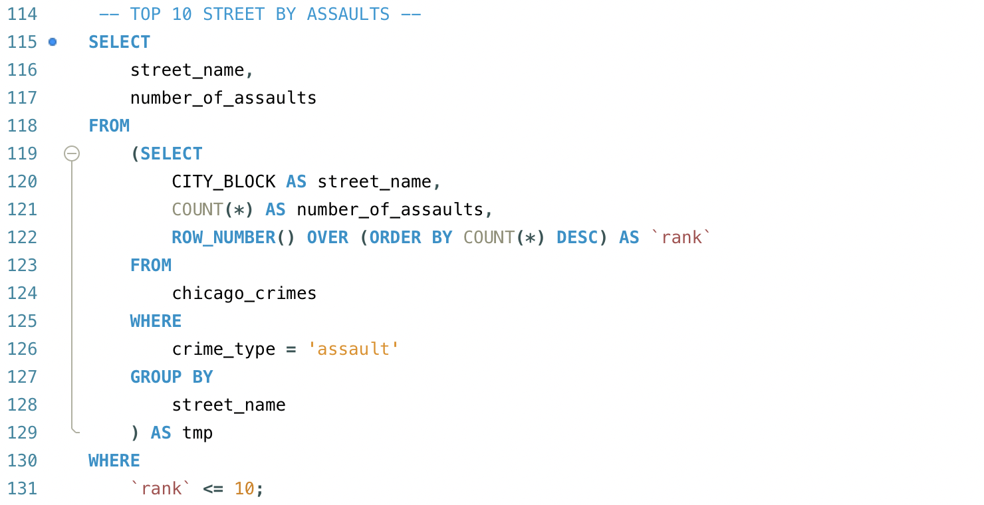

RESULT:

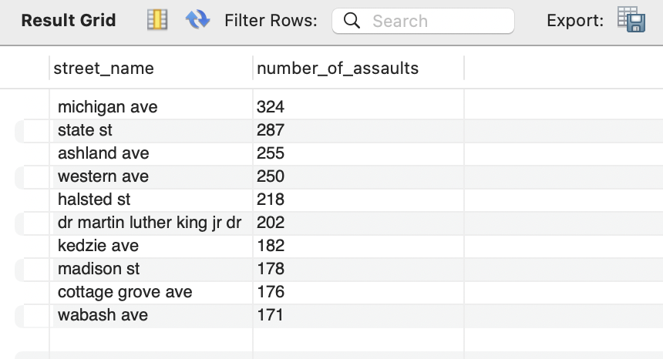

1. What are the number of different types of crimes committed within differing time ranges throughout the day?

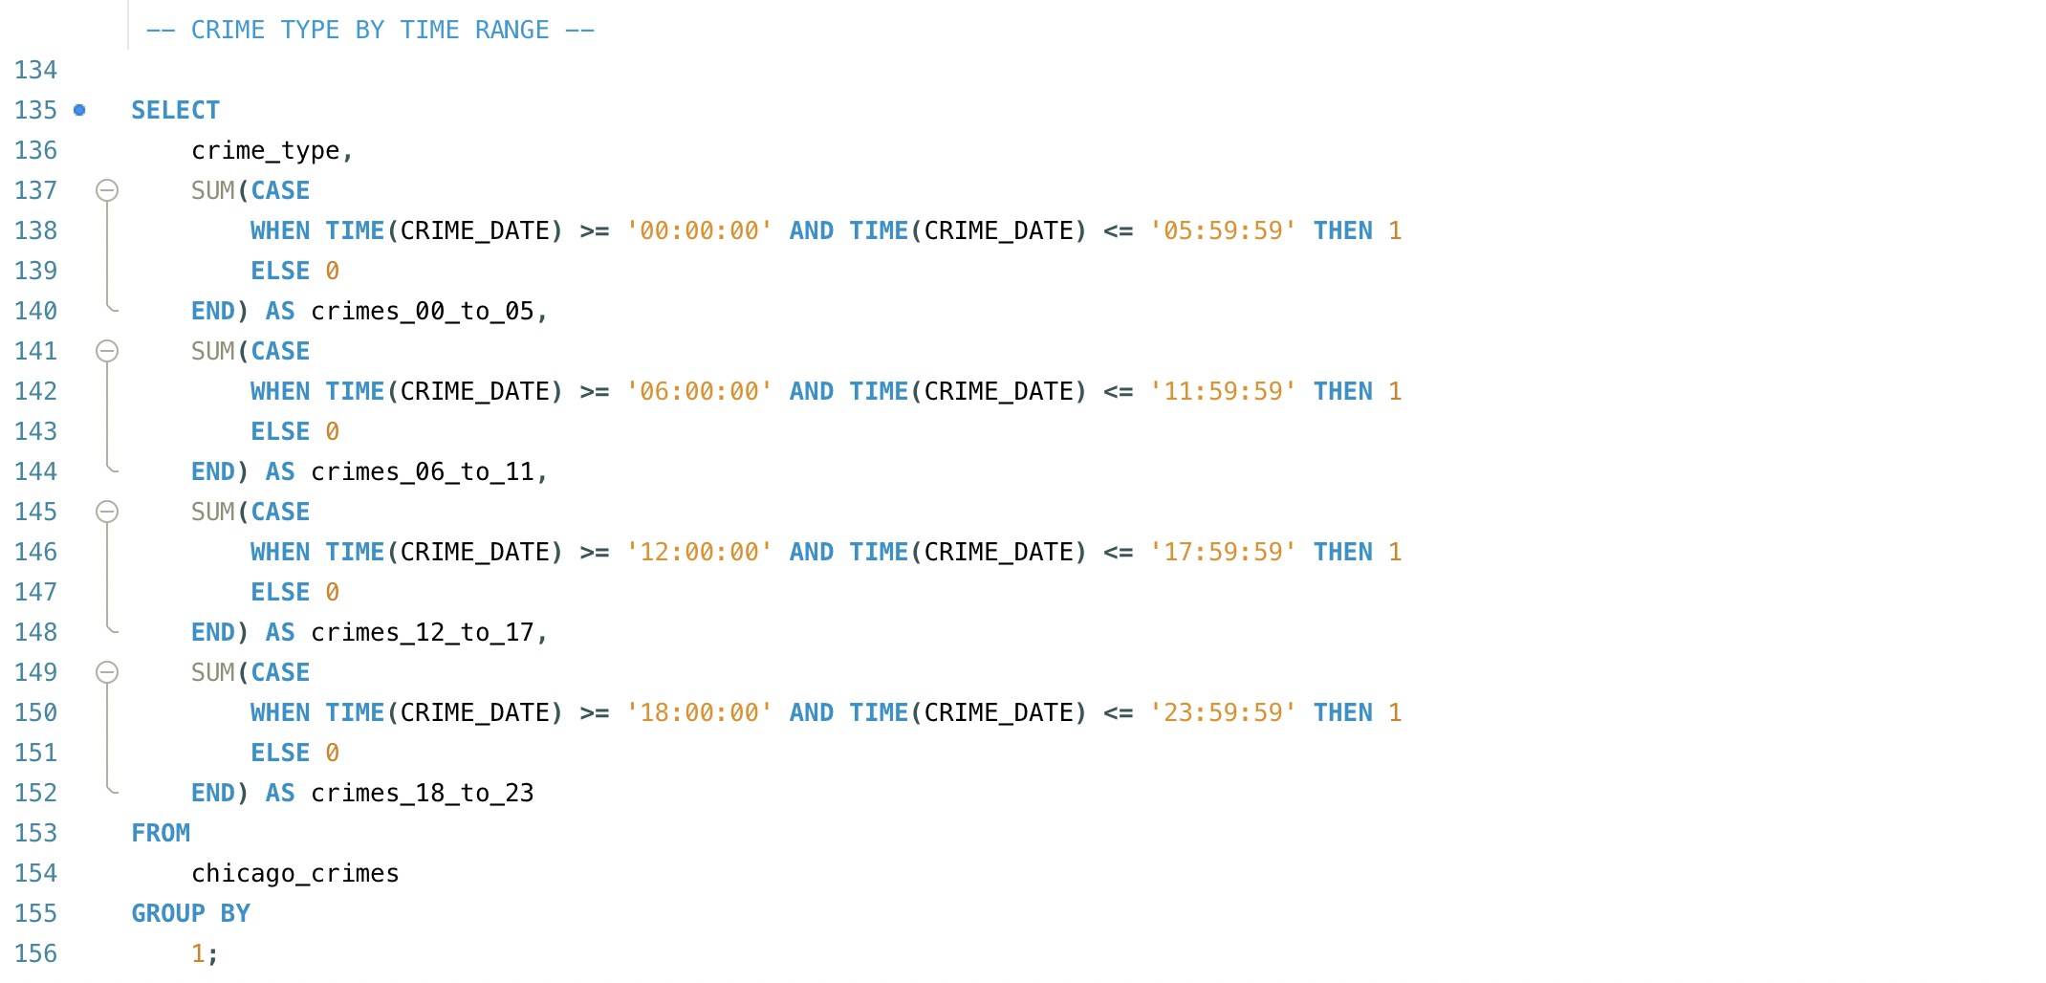

RESULT:

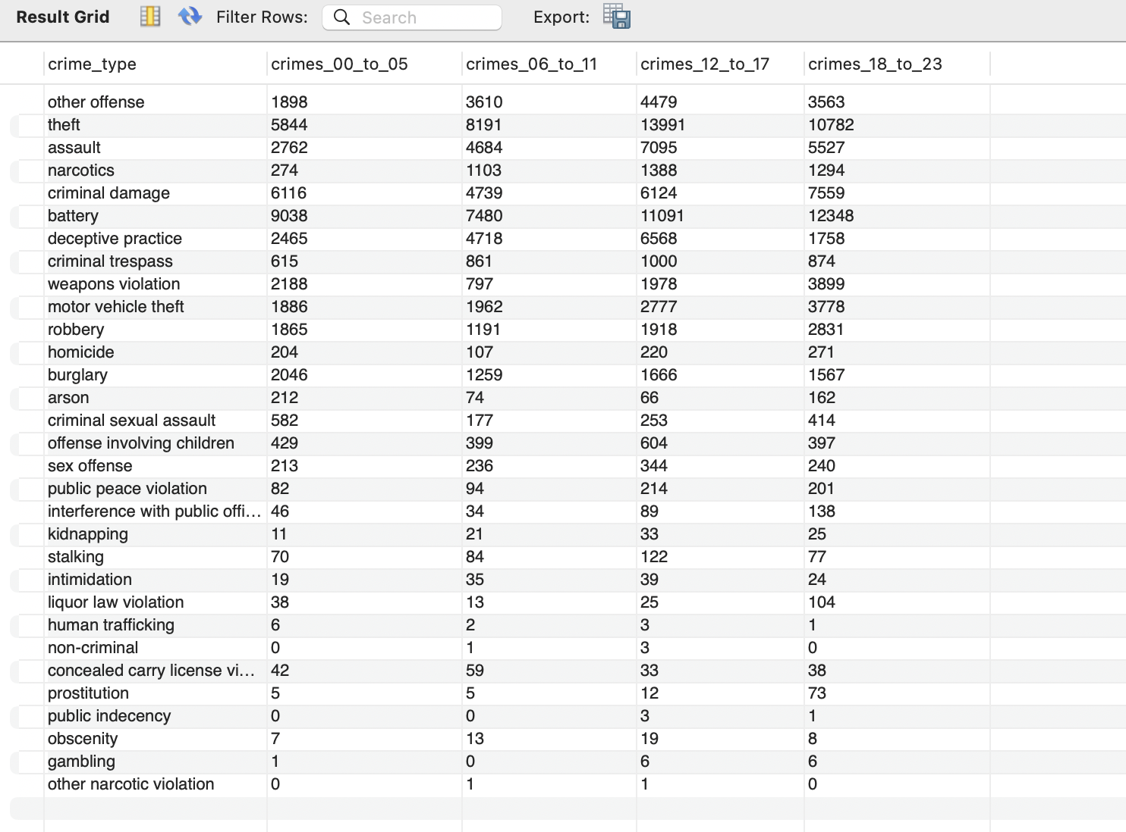

1. What are the number of crimes committed by the population count of the area ?

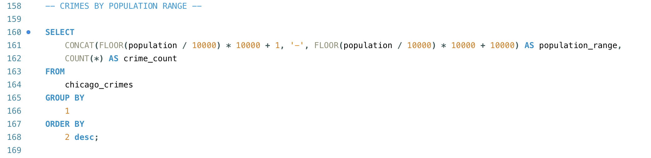

RESULT:

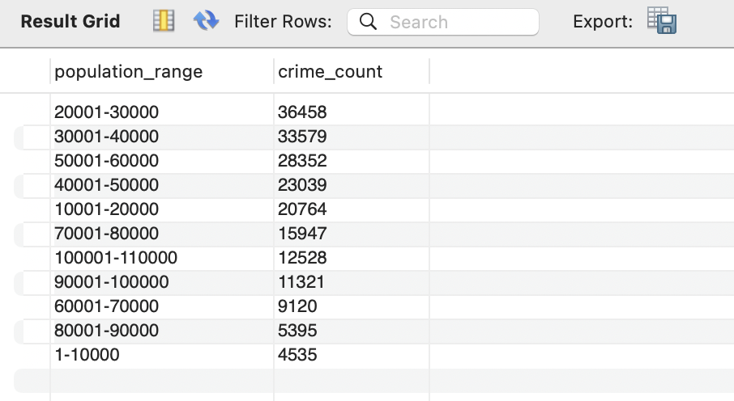

1. What are the top 10 most unsafe locations and how does the number of occurring crimes change by the weather?

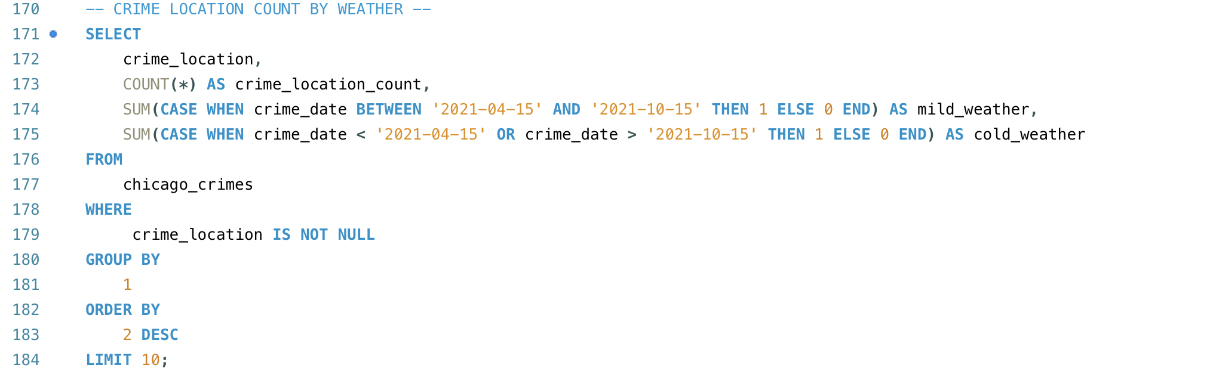

RESULT:

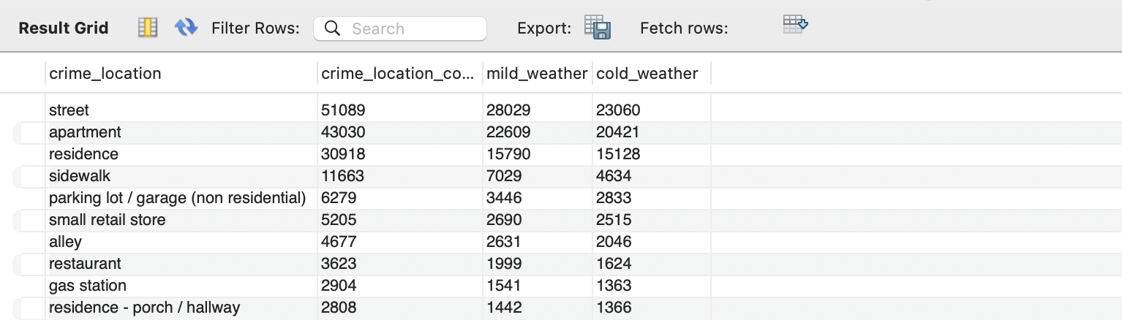

1. What are percentage of crimes committed are domestic in nature?

RESULT:

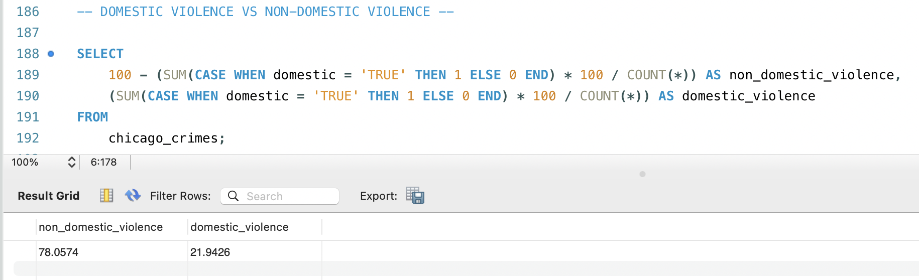

1. What are the monthly crime counts and the month-to-month percentage changes in crime occurrences?

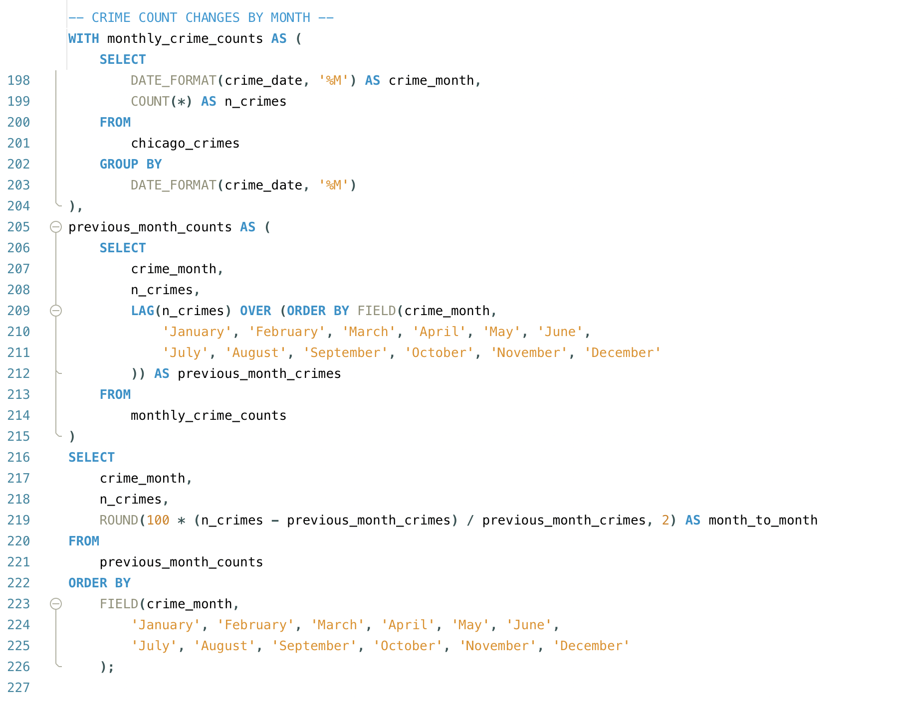

RESULT:

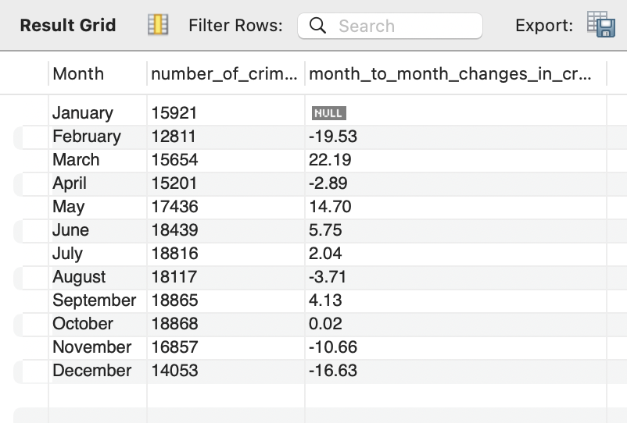

1. What are the total number of crimes committed by the day of the week?

RESULT:

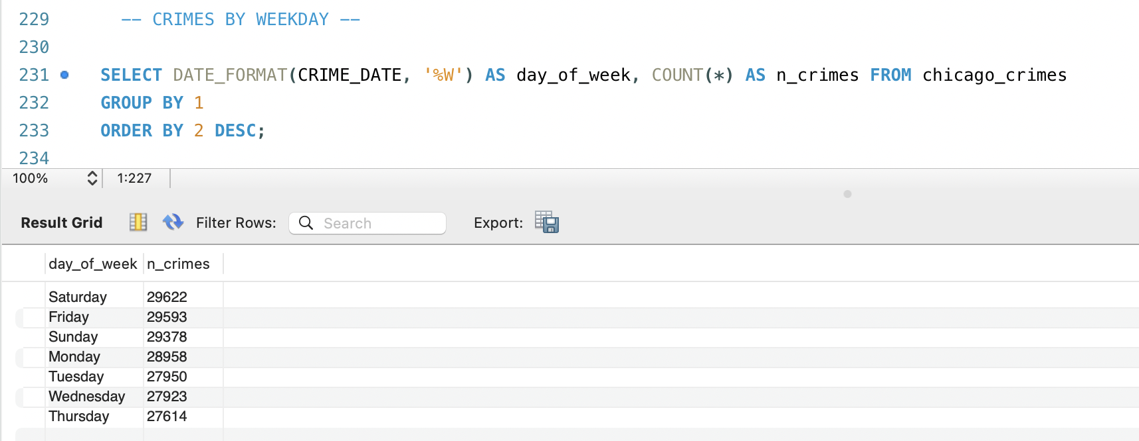

1. What are the top 10 most reported crimes, how many arrests were made and the percentage of arrests made?

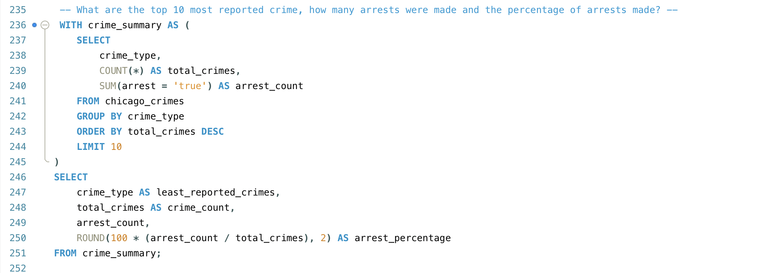

RESULT:

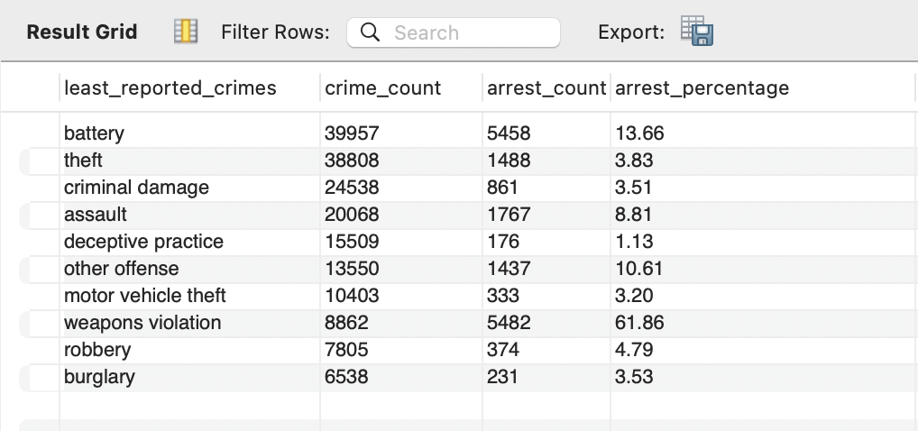

1. What are the percentage of total arrests made for all crimes committed in the city?

RESULT:

